AI LAB 1
EXPERIMENT 1 - BFS for Emergency Facility Navigation
AIM: To find a route through a hospital or emergency facility.
QUESTION:
Develop a Python-based navigation system for an emergency response team operating inside a hospital represented as an unweighted graph. Rooms and junctions are vertices, while accessible corridors are edges. Implement Breadth-First Search (BFS) to identify the route from the emergency entrance to a designated critical-care unit.
The program must:
- Represent the hospital layout as an adjacency list.
- Accept the source and destination nodes.
- Find and display the shortest route in terms of the number of corridors traversed.
- Report the number of nodes explored and explain how BFS guarantees a shortest path in an unweighted graph.

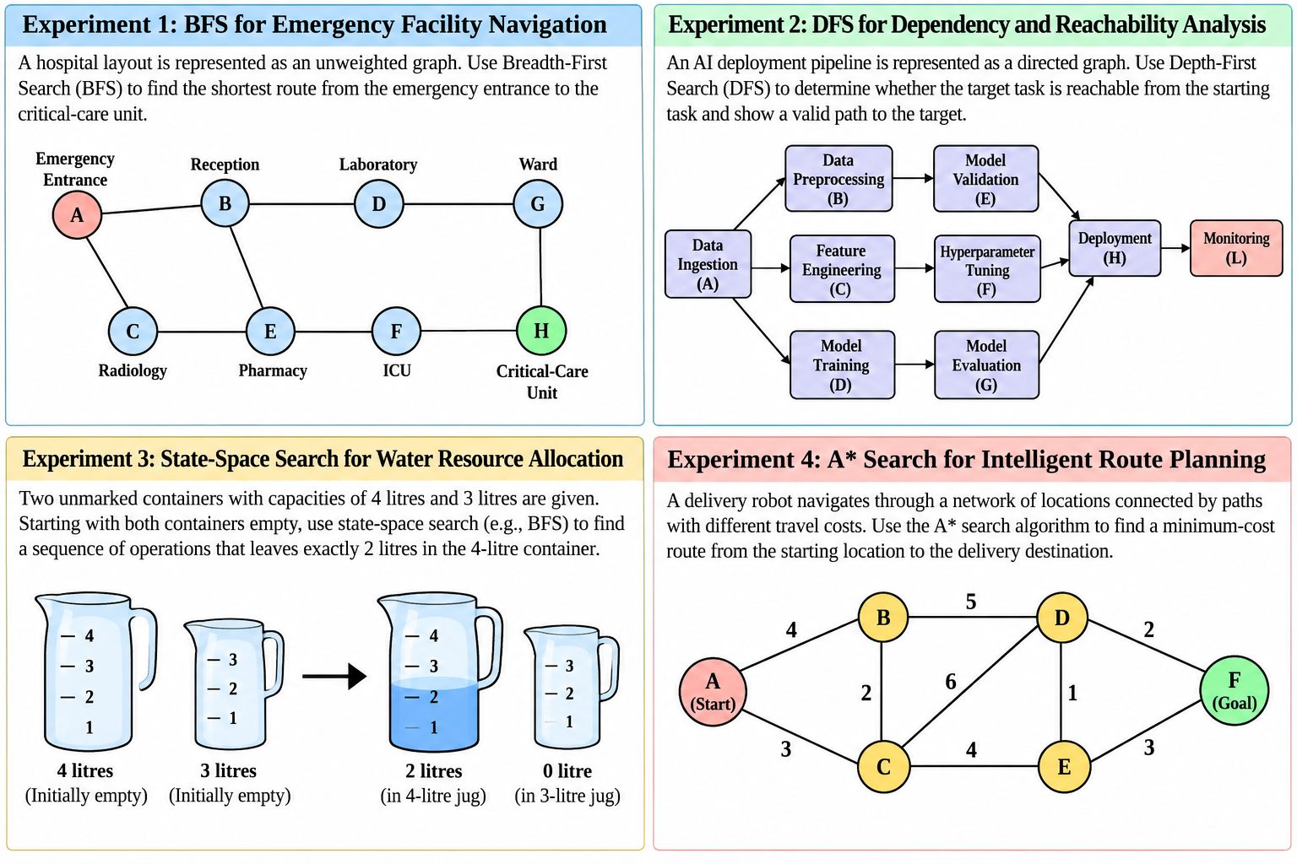
CODE:
from collections import deque

# Hospital layout represented as an adjacency list
graph = {
'A': ['B', 'C'],
'B': ['A', 'D', 'E'],
'C': ['A', 'E'],
'D': ['B', 'G'],
'E': ['B', 'C', 'F'],
'F': ['E', 'H'],
'G': ['D', 'H'],
'H': ['F', 'G']
}

def bfs(graph, source, destination):
queue = deque([(source, [source])])
visited = {source}
explored = 0

while queue:
node, path = queue.popleft()
explored += 1

if node == destination:
print("Shortest route:", " -> ".join(path))
print("Corridors traversed:", len(path) - 1)
print("Nodes explored:", explored)
return

for neighbor in graph[node]:
if neighbor not in visited:
visited.add(neighbor)
queue.append((neighbor, path + [neighbor]))

print("No route found.")

source = input("Enter source node (A-H): ").upper()
destination = input("Enter destination node (A-H): ").upper()

if source in graph and destination in graph:
bfs(graph, source, destination)
else:
print("Invalid node! Enter a node from A to H.")

OUTPUT:
Enter source node (A-H): A
Enter destination node (A-H): H
Shortest route: A -> B -> D -> G -> H
Corridors traversed: 4
Nodes explored: 8

EXPERIMENT 2 - DFS for Dependency and Reachability Analysis
AIM: To analyse dependencies in an AI software pipeline.
QUESTION:
An AI deployment pipeline consists of interconnected processing tasks, where each task depends on one or more downstream tasks. Model the pipeline as a directed graph and implement Depth-First Search (DFS) in Python to determine whether a specified target task is reachable from a given starting task.
The program must:
- Represent the pipeline using a directed adjacency list.
- Accept a starting task and a target task.
- Display the DFS traversal order and determine whether the target is reachable.
- Reconstruct a valid path to the target, if one exists.
- Explain how visited-node tracking prevents repeated exploration and how DFS behaves when the graph contains cycles.

CODE:

# Directed graph representing the AI deployment pipeline
graph = {
'A': ['B', 'C', 'D'],
'B': ['E'],
'C': ['F'],
'D': ['G'],
'E': ['H'],
'F': ['H'],
'G': ['H'],
'H': ['L'],
'L': []
}

def dfs(graph, start, target):
visited = set()
path = []
traversal = []

def search(node):
visited.add(node)
traversal.append(node)
path.append(node)

if node == target:
return True

for neighbor in graph[node]:
if neighbor not in visited:
if search(neighbor):
return True

path.pop()
return False

found = search(start)

print("DFS Traversal:", " -> ".join(traversal))

if found:
print("Target is reachable.")
print("Path:", " -> ".join(path))
else:
print("Target is not reachable.")

start = input("Enter starting task (A, B, C, D, E, F, G, H, L): ").upper()
target = input("Enter target task (A, B, C, D, E, F, G, H, L): ").upper()

if start in graph and target in graph:
dfs(graph, start, target)
else:
print("Invalid task!")

OUTPUT:
Enter starting task (A, B, C, D, E, F, G, H, L): A
Enter target task (A, B, C, D, E, F, G, H, L): H
DFS Traversal: A -> B -> E -> H
Target is reachable.
Path: A -> B -> -> H
EXPERIMENT 3 - State-Space Search for Water Resource Allocation
AIM: To Measure a target quantity using containers with fixed capacities.
QUESTION:
Design a Python-based state-space search solution for a water allocation problem involving two unmarked containers with capacities of 4 litres and 3 litres. Starting with both containers empty, determine a sequence of valid operations that leaves exactly 2 litres in the 4-litre container.
The program must:
- Represent each state as the quantities of water in both containers.
- Define the legal actions: fill, empty and transfer water between containers.
- Search the state space using BFS and identify a valid solution.
- Display the sequence of states and actions from the initial state to the goal.
- Explain how state representation, goal testing and repeated-state detection affect the search.
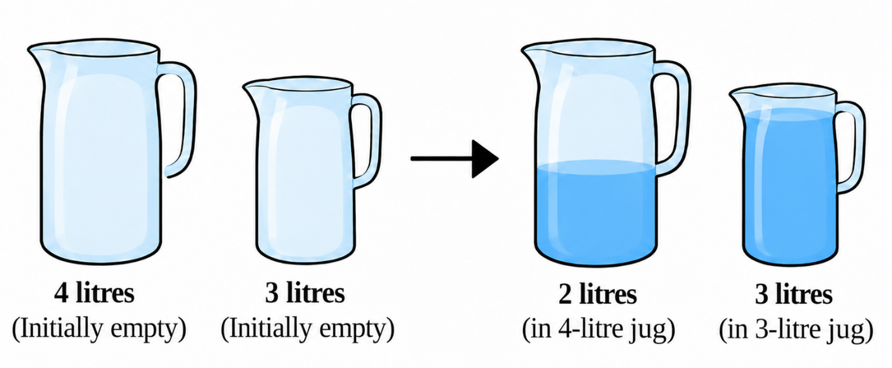

CODE:
from collections import deque

def get_next_states(state):
x, y = state
states = []

# Fill the 4-litre jug
states.append(((4, y), "Fill 4-litre jug"))

# Fill the 3-litre jug
states.append(((x, 3), "Fill 3-litre jug"))

# Empty the 4-litre jug
states.append(((0, y), "Empty 4-litre jug"))

# Empty the 3-litre jug
states.append(((x, 0), "Empty 3-litre jug"))

# Pour 4-litre jug into 3-litre jug
pour = min(x, 3 - y)
states.append(((x - pour, y + pour),
"Pour 4-litre jug into 3-litre jug"))

# Pour 3-litre jug into 4-litre jug
pour = min(y, 4 - x)
states.append(((x + pour, y - pour),
"Pour 3-litre jug into 4-litre jug"))

return states

def bfs():
start = (0, 0)
queue = deque([(start, [])])
visited = {start}

while queue:
state, path = queue.popleft()

# Goal: exactly 2 litres in the 4-litre jug
if state[0] == 2:
print("Solution found!")
print("Initial state:", start)

for action, next_state in path:
print(action, "->", next_state)

print("Goal state:", state)
return

for next_state, action in get_next_states(state):
if next_state not in visited:
visited.add(next_state)
queue.append(
(next_state, path + [(action, next_state)])
)

print("No solution found.")

bfs()

OUTPUT:
Solution found!
Initial state: (0, 0)
Fill 4-litre jug -> (4, 0)
Pour 4-litre jug into 3-litre jug -> (1, 3)
Empty 3-litre jug -> (1, 0)
Pour 4-litre jug into 3-litre jug -> (0, 1)
Fill 4-litre jug -> (4, 1)
Pour 4-litre jug into 3-litre jug -> (2, 3)
Goal state: (2, 3)

EXPERIMENT 4 - A* Search for Intelligent Route Planning
APPLICATION: To route planning for an autonomous delivery robot.
QUESTION
Develop an intelligent route-planning system for an autonomous delivery robot navigating a network of locations connected by paths with different travel costs. Implement the A* search algorithm in Python to find a minimum-cost route from a specified starting location to a delivery destination.
The program must:
- Represent the environment as a weighted graph.
- Assign a heuristic estimate \(h(n)\) to each node and calculate the accumulated path cost \(g(n)\).
- Use \(f(n)=g(n)+h(n)\) to determine which node to explore next.
- Display the selected route, total path cost and node expansion order.
- Explain how heuristic quality affects search efficiency and why an admissible heuristic matters for optimality.
Heuristic values.
Node | h(n)
A | 6
B | 4
C | 5
D | 2
E | 3
F | 0

CODE:
import heapq

# Weighted graph representing the locations
graph = {
'A': {'B': 4, 'C': 3},
'B': {'A': 4, 'C': 2, 'D': 5},
'C': {'A': 3, 'B': 2, 'D': 6, 'E': 4},
'D': {'B': 5, 'C': 6, 'E': 1, 'F': 2},
'E': {'C': 4, 'D': 1, 'F': 3},
'F': {'D': 2, 'E': 3}
}

# Admissible heuristic estimates to goal F
h = {
'A': 6,
'B': 4,
'C': 4,
'D': 2,
'E': 2,
'F': 0
}

def astar(start, goal):
queue = [(h[start], 0, start)]
parent = {}
cost = {start: 0}
expanded = []

while queue:
f, g, node = heapq.heappop(queue)

if g != cost[node]:
continue

expanded.append(node)

if node == goal:
path = []
current = goal

while current != start:
path.append(current)
current = parent[current]

path.append(start)
path.reverse()

print("Selected route:", " -> ".join(path))
print("Total path cost:", cost[goal])
print("Node expansion order:", " -> ".join(expanded))
return

for neighbor, weight in graph[node].items():
new_cost = g + weight

if new_cost < cost.get(neighbor, float('inf')):
cost[neighbor] = new_cost
parent[neighbor] = node
f_value = new_cost + h[neighbor]

heapq.heappush(
queue, (f_value, new_cost, neighbor)
)

print("No route found.")

start = input("Enter start node (A-F): ").upper()
goal = input("Enter goal node (A-F): ").upper()

if start in graph and goal in graph:
astar(start, goal)
else:
print("Invalid node!")

OUTPUT:
Optimal path : A -> C -> E -> F
Total path cost : 10
Nodes expanded : 6
Expansion order : A -> B -> C -> E -> D -> F

Experiment 5: Solving the 8-Queens Problem Using Backtracking
AIM: To find the collision-free placement of components on a grid.
QUESTION:
An automated placement system must position eight components on an 8 × 8 grid such that no two components interfere with one another. Model this as the 8-Queens problem, where each queen represents a component and can attack another queen along the same row, column, or diagonal.
Develop a Python program using the backtracking algorithm to find a valid arrangement of eight queens on the chessboard.
The program must:
- Represent the chessboard as an 8 × 8 grid and track the positions of the queens.
- Place one queen at a time while ensuring that no two queens share the same row, column, or diagonal.
- Use recursive backtracking to undo an invalid placement and explore alternative positions.
- Display the final chessboard arrangement and the positions of all eight queens.
- Report the number of placement attempts and explain how constraint checking and backtracking help find a valid solution.

CODE:
N = 8

# Store the column position of each queen
board = [-1] * N

attempts = 0

# Function to check whether a queen can be placed safely
def is_safe(row, col):
for i in range(row):
# Check same column
if board[i] == col:
return False

# Check diagonal attacks
if abs(board[i] - col) == abs(i - row):
return False

return True

# Recursive backtracking function
def solve(row):
global attempts

# All eight queens are placed
if row == N:
return True

# Try placing queen in each column
for col in range(N):
attempts += 1

if is_safe(row, col):
board[row] = col

# Recursively place the next queen
if solve(row + 1):
return True

# Backtrack if no solution is found
board[row] = -1

return False

# Execute the algorithm
if solve(0):
print("Valid 8-Queens Solution:\n")

# Display chessboard
for row in range(N):
for col in range(N):
if board[row] == col:
print(" Q ", end="")
else:
print(" . ", end="")
print()

# Display queen positions
print("\nQueen Positions:")
for row in range(N):
print(f"Queen {row + 1}: Row {row + 1}, Column {board[row] + 1}")

print("\nTotal Placement Attempts:", attempts)

else:
print("No solution exists.")

OUTPUT:
Valid 8-Queens Solution:

Q . . . . . . .
. . . . Q . . .
. . . . . . . Q
. . . . . Q . .
. . Q . . . . .
. . . . . . Q .
. Q . . . . . .
. . . Q . . . .

Queen Positions:
Queen 1: Row 1, Column 1
Queen 2: Row 2, Column 5
Queen 3: Row 3, Column 8
Queen 4: Row 4, Column 6
Queen 5: Row 5, Column 3
Queen 6: Row 6, Column 7
Queen 7: Row 7, Column 2
Queen 8: Row 8, Column 4

Total Placement Attempts: 876

Experiment 6: Solving the Map Colouring Problem Using CSP
AIM: To make frequency allocation for neighbouring cellular network regions.
QUESTION:
A telecommunications network is divided into interconnected regions. To reduce interference, neighbouring regions must be assigned different frequency bands. Model the network as a Constraint Satisfaction Problem (CSP), where each region is a variable, the available frequency bands form its domain, and neighbouring regions must receive different assignments.
Develop a Python program to solve the map-colouring problem using CSP techniques.
The program must:
- Represent each region as a variable and define its available colours as a domain.
- Specify adjacency constraints requiring neighbouring regions to have different colours.
- Use backtracking search to find a valid colour assignment.
- Display the final map-colouring assignment and verify that all adjacency constraints are satisfied.
- Report the number of assignments attempted and explain how CSP variables, domains, and constraints guide the search.
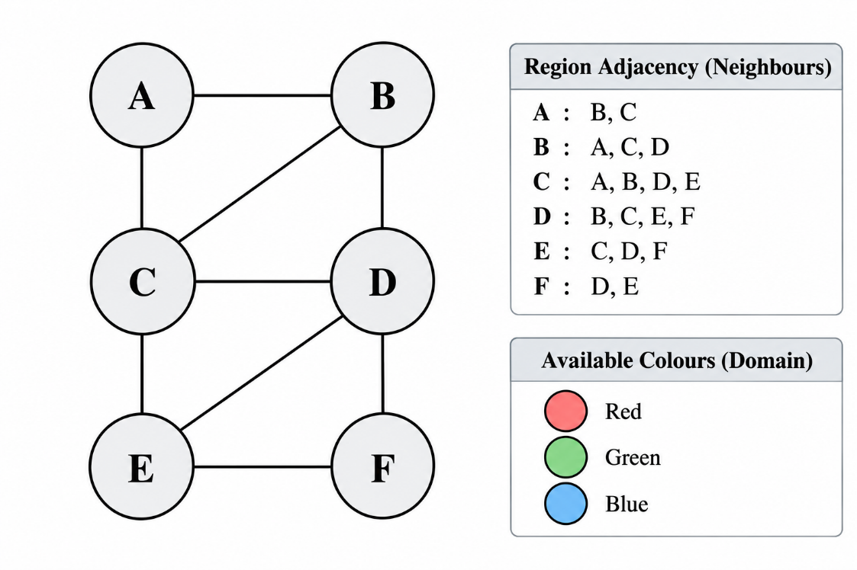

CODE:
# 1. Define CSP variables (regions)
regions = ['A', 'B', 'C', 'D', 'E', 'F']

# 2. Define available colours (domains)
colours = ['Red', 'Green', 'Blue']

domains = {
region: colours.copy() for region in regions
}

# 3. Define adjacency constraints
neighbours = {
'A': ['B', 'C'],
'B': ['A', 'C', 'D'],
'C': ['A', 'B', 'D', 'E'],
'D': ['B', 'C', 'E', 'F'],
'E': ['C', 'D', 'F'],
'F': ['D', 'E']
}

# Store colour assignments
assignment = {}

# Count assignment attempts
attempts = 0

# Check whether a colour is valid
def is_valid(region, colour):
for neighbour in neighbours[region]:
if neighbour in assignment:
if assignment[neighbour] == colour:
return False
return True

# 4. Backtracking search
def backtrack():
global attempts

# Check whether all regions are coloured
if len(assignment) == len(regions):
return True

# Select an unassigned region
region = next(r for r in regions if r not in assignment)

# Try each colour in its domain
for colour in domains[region]:
attempts += 1

if is_valid(region, colour):
assignment[region] = colour

if backtrack():
return True

# Backtrack
del assignment[region]

return False

# 5. Execute CSP algorithm
if backtrack():
print("Valid Map Colouring Assignment:\n")

for region in regions:
print(f"Region {region} : {assignment[region]}")

# Verify adjacency constraints
print("\nConstraint Verification:")

valid = True

for region in regions:
for neighbour in neighbours[region]:
if assignment[region] == assignment[neighbour]:
valid = False
print(f"Conflict between {region} and {neighbour}")

if valid:
print("All adjacency constraints are satisfied.")

print("\nTotal Assignment Attempts:", attempts)

else:
print("No valid colouring exists.")
OUTPUT:
Valid Map Colouring Assignment:

Region A : Red
Region B : Green
Region C : Blue
Region D : Red
Region E : Green
Region F : Blue

Constraint Verification:
All adjacency constraints are satisfied.

Total Assignment Attempts: 12

Experiment 7 - Implementing the Minimax Algorithm
AIM: To demonstrate decision-making in a two-player strategy game.
QUESTION:
A game-playing AI must select its best move in a two-player game where one player tries to maximize the score while the opponent tries to minimize it.
Develop a Python program to implement the Minimax algorithm for a game represented as a binary game tree. The program must:
- Represent the game tree with terminal utility values.
- Treat the AI as the maximizing player and the opponent as the minimizing player.
- Recursively evaluate the game tree using the Minimax algorithm.
- Display the evaluated values and the best move selected by the AI.
- Explain how the algorithm assumes that both players choose optimal moves.

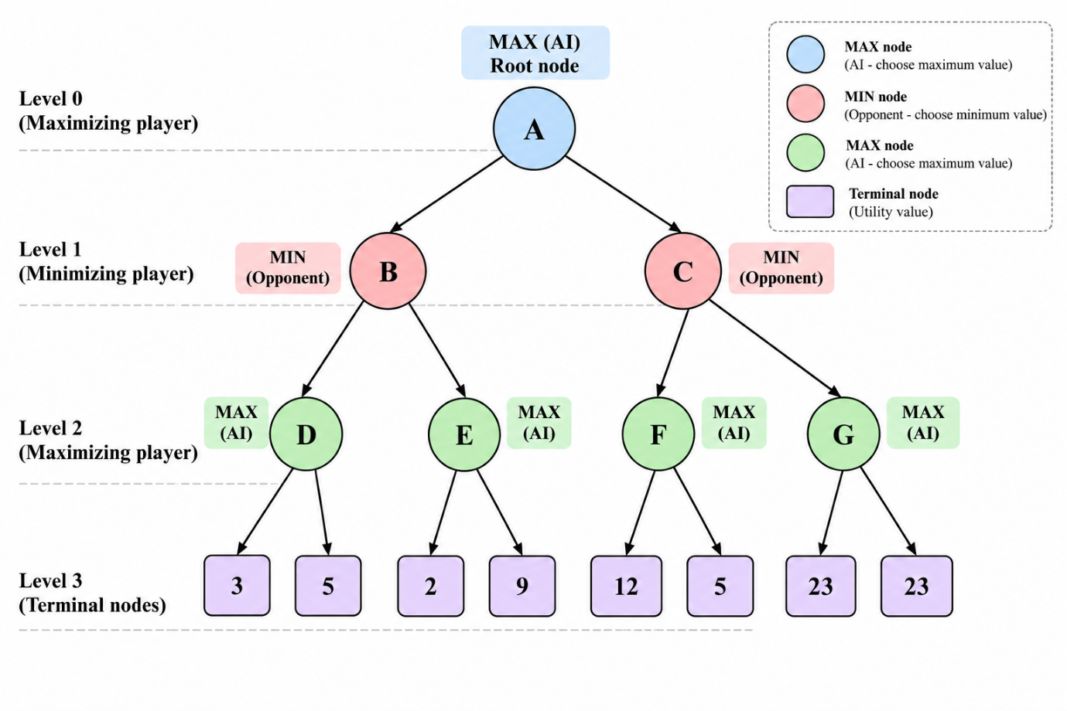

CODE:
# Binary game tree with terminal utility values
tree = [
[3, 5],
[2, 9]
]

def minimax(node, maximizing):
if isinstance(node, int):
return node

if maximizing:
values = [minimax(child, False) for child in node]
result = max(values)
print("Max values:", values, "->", result)
return result
else:
values = [minimax(child, True) for child in node]
result = min(values)
print("Min values:", values, "->", result)
return result

best_value = minimax(tree, True)

print("\nBest value for AI:", best_value)
print("Best move: First branch (left)")

OUTPUT:
Min values: [3, 5] -> 3
Min values: [2, 9] -> 2
Max values: [3, 2] -> 3

Best value for AI: 3
Best move: First branch (left)

Experiment 8 - Implementing Alpha-Beta Pruning
AIM: To optimize decision-making in a two-player strategy game.
QUESTION:
A chess-playing AI evaluates possible moves by exploring a game tree. Since evaluating every possible move is computationally expensive, the AI uses Alpha-Beta Pruning to eliminate branches that cannot influence the final decision.
Develop a Python program to implement the Alpha-Beta Pruning algorithm for a chess-inspired game tree with multiple possible moves and terminal utility values.
The program must:
- Represent the game tree with multiple candidate moves and terminal utility values.
- Implement Alpha-Beta Pruning using alpha and beta bounds.
- Identify and skip branches that cannot affect the final decision.
- Display the selected move, its utility value, the number of nodes evaluated, and the number of branches pruned.
- Explain how Alpha-Beta Pruning reduces the search effort while preserving the optimal decision.

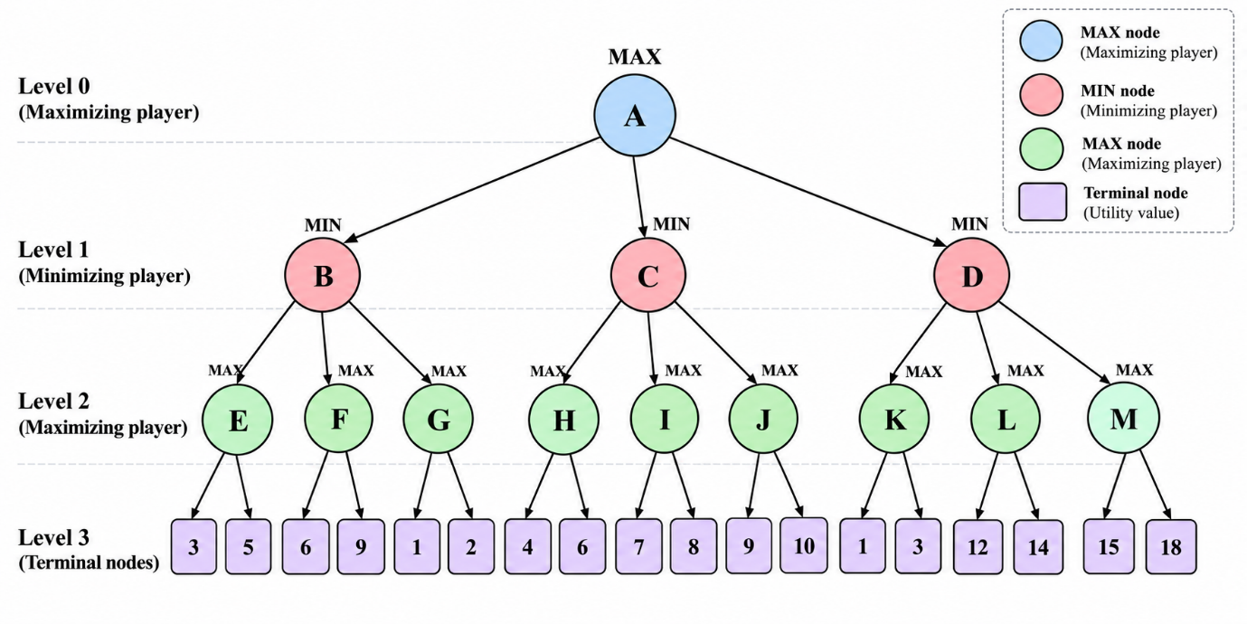

CODE:
tree = [
[3, 5],
[2, 9]
]

nodes_evaluated = 0
branches_pruned = 0

def alpha_beta(node, alpha, beta, maximizing):
global nodes_evaluated, branches_pruned

if isinstance(node, int):
nodes_evaluated += 1
print("Evaluating:", node)
return node

if maximizing:
value = float('-inf')

for i, child in enumerate(node):
value = max(value, alpha_beta(child, alpha, beta, False))
alpha = max(alpha, value)

if alpha >= beta:
branches_pruned += len(node) - i - 1
print("Pruned remaining branches:", len(node) - i - 1)
break

return value

else:
value = float('inf')

for i, child in enumerate(node):
value = min(value, alpha_beta(child, alpha, beta, True))
beta = min(beta, value)

if beta <= alpha:
branches_pruned += len(node) - i - 1
print("Pruned remaining branches:", len(node) - i - 1)
break

return value

best_value = alpha_beta(tree, float('-inf'),
float('inf'), True)

print("\nBest value for AI:", best_value)
print("Best move: First branch (left)")
print("Nodes evaluated:", nodes_evaluated)
print("Branches pruned:", branches_pruned)

OUTPUT:
Evaluating: 3
Evaluating: 5
Evaluating: 2
Pruned remaining branches: 1

Best value for AI: 3
Best move: First branch (left)
Nodes evaluated: 3
Branches pruned: 1

EXPERIMENT 9 - Forward Chaining
AIM: To implement forward chaining using rule-based medical appointment eligibility.
QUESTION:
A healthcare appointment system uses facts and logical rules to determine whether a patient is eligible for a priority consultation. The system derives new facts from existing information by repeatedly applying rules until a conclusion is reached or no further facts can be inferred.
Develop a Python program to implement Forward Chaining using facts and rules.
The program must:
- Represent the initial facts and inference rules.
- Check whether the conditions of each rule are satisfied.
- Infer and add new facts when a rule applies.
- Continue the inference process until no new facts can be derived.
- Display the initial facts, newly inferred facts, and final set of facts.
CODE:
# Step 1: Initial facts
facts = {
"patient_registered",
"has_severe_symptoms",
"doctor_available"
}

# Step 2: Define rules
rules = [
({"patient_registered"}, "verified_patient"),
({"has_severe_symptoms"}, "priority_required"),
({"verified_patient", "priority_required"},
"priority_eligible"),
({"priority_eligible", "doctor_available"},
"priority_appointment")
]

# Step 3: Forward Chaining
print("Initial Facts:")
print(facts)

print("\nNewly Inferred Facts:")

while True:
new_fact_added = False

for conditions, conclusion in rules:
if conditions.issubset(facts) and conclusion not in facts:
facts.add(conclusion)
print("Inferred:", conclusion)
new_fact_added = True

if not new_fact_added:
break

# Step 4: Display final facts
print("\nFinal Set of Facts:")
print(facts)

# Step 5: Display result
if "priority_appointment" in facts:
print("\nResult: Patient is eligible for priority consultation.")
else:
print("\nResult: Patient is not eligible for priority consultation.")

OUTPUT:
Initial Facts:
{'patient_registered', 'has_severe_symptoms',
'doctor_available'}

Newly Inferred Facts:
Inferred: verified_patient
Inferred: priority_required
Inferred: priority_eligible
Inferred: priority_appointment

Final Set of Facts:
{'patient_registered', 'has_severe_symptoms',
'doctor_available', 'verified_patient',
'priority_required', 'priority_eligible',
'priority_appointment'}

Result: Patient is eligible for priority consultation.

EXPERIMENT 10 - Resolution Refutation
AIM: To verify whether a student qualifies as a happy student using logical statements.
QUESTION:
A university models student well-being using logical facts and rules. It wants to determine whether a student is happy based on the conditions that the student enjoys learning and has sufficient free time.
Develop a Python program to implement Resolution Refutation to prove whether a student is happy.
The program must:
- Represent the knowledge base using logical statements.
- Convert the relevant statements into Conjunctive Normal Form (CNF).
- Negate the goal to be proved and add it to the knowledge base.
- Apply the resolution rule to derive new clauses.
- Identify the empty clause, if obtained, to demonstrate a contradiction and establish the goal.
CODE:
# Step 1: Knowledge Base in CNF
# Enjoys learning = E
# Has free time = F
# Happy student = H

clauses = [
{"E"}, # Student enjoys learning
{"F"}, # Student has sufficient free time
{"~E", "~F", "H"} # E AND F implies H
]

print("Initial Knowledge Base:")
for c in clauses:
print(c)

# Step 2: Negate the goal
# Goal: H
# Negated goal: ~H

clauses.append({"~H"})

print("\nAfter adding negated goal:")
for c in clauses:
print(c)

# Step 3: Resolution function
def resolve(c1, c2):
for literal in c1:
if literal.startswith("~"):
opposite = literal[1:]
else:
opposite = "~" + literal

if opposite in c2:
new_clause = (c1 - {literal}) | (c2 - {opposite})
return new_clause

return None

# Step 4: Apply resolution
print("\nResolution Steps:")

new_clauses = []

while True:
found = False

for i in range(len(clauses)):
for j in range(i + 1, len(clauses)):

result = resolve(clauses[i], clauses[j])

if result is not None and result not in clauses:
print(clauses[i], "+", clauses[j], "=", result)

clauses.append(result)
found = True

if len(result) == 0:
print("\nEmpty clause obtained!")
print("Contradiction found.")
print("Therefore, the student is HAPPY.")
raise SystemExit

if not found:
break

print("\nNo empty clause obtained.")
print("The goal could not be proved.")

OUTPUT:
Initial Knowledge Base:
{'E'}
{'F'}
{'~E', '~F', 'H'}

After adding negated goal:
{'E'}
{'F'}
{'~E', '~F', 'H'}
{'~H'}

Resolution Steps:
{'E'} + {'~E', '~F', 'H'} = {'~F', 'H'}
{'F'} + {'~F', 'H'} = {'H'}
{'~H'} + {'H'} = set()

Empty clause obtained!
Contradiction found.
Therefore, the student is HAPPY.

EXPERIMENT 11: Family Tree
AIM: To represent family relationships in an expert system.
QUESTION:
Develop a program to represent family relationships using facts and rules. Given a family tree, identify the parents, children, and grandparents of specified individuals.
CODE:
# Step 1: Define parent facts
parent = [
("John", "David"),
("Mary", "David"),
("John", "Sarah"),
("Mary", "Sarah"),
("David", "Peter"),
("Lisa", "Peter"),
("Sarah", "Emma"),
("Robert", "Emma")
]

# Step 2: Find parents
def find_parents(person):
print("\nParents of", person, ":")
for p, child in parent:
if child == person:
print(p)

# Step 3: Find children
def find_children(person):
print("\nChildren of", person, ":")
for p, child in parent:
if p == person:
print(child)

# Step 4: Find grandparents
def find_grandparents(person):
print("\nGrandparents of", person, ":")
for p, child in parent:
if child == person:
for gp, parent_name in parent:
if parent_name == p:
print(gp)

# Step 5: Display relationships
find_parents("David")
find_children("John")
find_grandparents("Peter")
OUTPUT:
Parents of David:
John
Mary

Children of John:
David
Sarah

Grandparents of Peter:
John
Mary

EXPERIMENT 12: Pattern Matching in a Healthcare Symptom Assessment System
AIM: To implement rule-based healthcare support for preliminary symptom assessment.
QUESTION:
A healthcare support system receives a patient's description of symptoms in natural language. The system must identify relevant symptom keywords and phrases, match them against predefined rules, and return suitable guidance or recommend professional assessment.
Develop a Python program that applies pattern matching to patient-reported symptoms and identifies predefined symptom patterns to generate relevant guidance.
CODE:
# Step 1: Define symptom patterns and guidance
rules = {
"fever": [
"fever", "high temperature", "body heat"
],
"cold": [
"cold", "sneezing", "runny nose"
],
"headache": [
"headache", "head pain"
],
"stomach_problem": [
"stomach pain", "stomach ache", "vomiting"
]
}

# Step 2: Define guidance for each pattern
guidance = {
"fever": "Monitor temperature and consult a doctor if symptoms persist.",
"cold": "Take adequate rest and seek medical advice if symptoms worsen.",
"headache": "Rest and consult a healthcare professional if severe or persistent.",
"stomach_problem": "Seek medical advice for proper assessment."
}

# Step 3: Get patient symptoms
symptoms = input("Enter your symptoms: ").lower()

# Step 4: Pattern matching
matched = False

print("\nSymptom Assessment:")

for pattern, keywords in rules.items():
for keyword in keywords:
if keyword in symptoms:
print("Identified Pattern:", pattern)
print("Guidance:", guidance[pattern])
matched = True
break

# Step 5: Display result
if not matched:
print("No predefined symptom pattern found.")
print("Please consult a healthcare professional for assessment.")

print("\nAssessment Completed.")

OUTPUT:
Input:
Enter your symptoms: I have fever and headache
Output:
Symptom Assessment:

Identified Pattern: fever
Guidance: Monitor temperature and consult a doctor if symptoms persist.

Identified Pattern: headache
Guidance: Rest and consult a healthcare professional if severe or persistent.

Assessment Completed.

